**Validation of Rapid Mixer Granulator**

**Opération qualification**

Following are the contents of equipment opération qualification:

1. Application S.O.P’s,

2. Utilization List,

3. Process Description,

4.Test Instrument Utilized To Conduct Test,

5.Test Instrument Calibration,

6. Critical Parameters,

7. Test Function (List),

8. Test Function Summaries

**RAPID MIXER GRANUALATOR**

1. Homogenous mixing of dry & wet powders, deaglomeration of wet mass and fast dispersion of binding agent.

2. Dust free, high free flowing dosing particles, high uniformity of granule size.

3. Frequency control for bottom driven Impeller Mixer with 3 or 4 blades with exclusive scrape side design and Chopper positioned to make granules.

**Installation Qualification:**

• An IQ establishes confidence that the equipment is properly installed. The installation must meet the manufacturer's

specified guidelines, along with design changes at installation. Also the supporting electrical utilities must meet all electrical codes.

* · Equipment control functions:
* · Impeller, timer, bowl on/off & slow/fast
* buttons.
* · Emergency, discharge port on/off
* · Alarm, wash down walls on/off

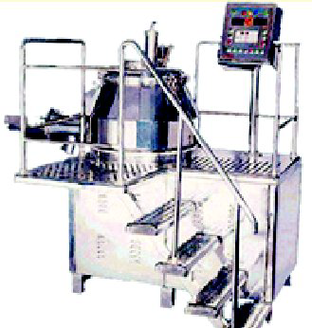

Rapid mixer granulator

**Equipment identification:**

· Record the equipment identification number, with equipment manufacturer, purchase order, model number, and equipment number.

**Required Documentation:**

* The manufacturers operation and maintenance
* manual and SOPs that cover the set up.
* · Utility requirements
* · Power
* · Water
* · Compressed air, spraying, impeller
* movement, pneumatic discharge port

**Calibration Requirements:**

* **· Ammeter**
* **· Voltmeter**
* **· Water pressure gauge**
* **· Air pressure gauge**
* **· Equipment major specifications:**
* **· Mixing bowl material of contact, surface finishing, dimensions, capacity.**
* **· Motors two are required**
* **· Discharge port**
* **· Lid**
* **· Liquid air dispersing system**
* **· Nozzle**
* **· Components coming in contact with**
* **product**
* **· Lubrication/ filter**

Equipment Safety Features:

* Emergency stop button, barrier guard,
* electrical inter locking system, alarms

**Control Functions:**

* Regulators, discharge port opening,
* spraying button Operational Qualification:
* · Calibration requirements for temp, timer,
* pressure gauges, ammeter